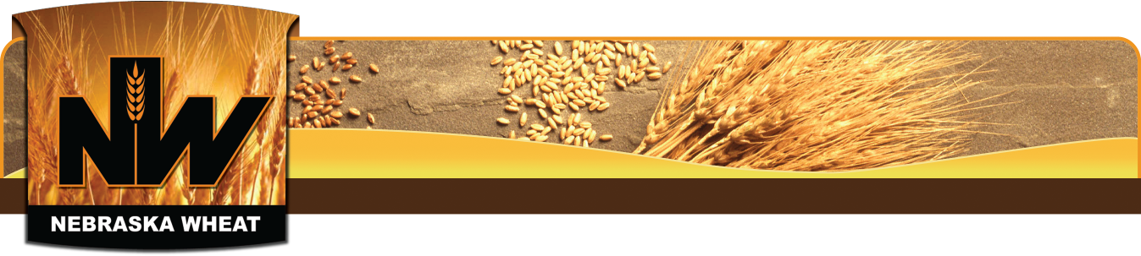
Nebraska Wheat Board Ambassador Program
Application Form
Please complete and submit by mail or email to the contact listed below.
Application due: July 24, 2020

Sarah Morton
Nebraska Wheat Board
301 Centennial Mall South, PO Box 94912, Lincoln, NE 68509
402-471-4872 | sarah.morton@nebraska.gov

Name: Click or tap here to enter text.
Permanent Address: Click or tap here to enter text.
City: Click or tap here to enter text. State: Click or tap here to enter text. Zip Code: Click or tap here to enter text.
Email: Click or tap here to enter text. Phone: Click or tap here to enter text.
DOB: Click or tap to enter a date. College/University: Click or tap here to enter text.
Major: Click or tap here to enter text. Class Standing (ie: sophomore): Click or tap here to enter text.
Hometown Newspaper: Click or tap here to enter text.

In your opinion, what is one issue currently affecting the wheat industry?
Click or tap here to enter text.

Why would you be a good advocate for the wheat industry?
Click or tap here to enter text.

Why do you want to be a wheat ambassador?
Click or tap here to enter text.

In addition to filling out this application, please submit the following:
- Current resume
- Three references
- Current transcript

